Implementation of OAIS Modeling and SPBE Principles to Design National Archival Platform System Using the Microservice-Based SCSE Framework

Taufik Iqbal Ramdhani¹, Ninon Nurul Faiza¹²
¹Research Center for Data and Information Sciences, National Research and Innovation Agency, Bandung, Indonesia
²School of Electrical and Informatics Engineering. Bandung Technology University, Bandung, Indonesia

Article Info |  | ABSTRACT (10 PT)
Article history:  Received month dd, yyyy  Revised month dd, yyyy  Accepted month dd, yyyy |  | Archives have a strategic role as information and recorded events regarding the dynamics of social and national life are sources of objective information concerning various fields of politics, society, economics, culture, science, and technology. The acceleration of digital transformation triggers the implementation of a smart government that supports better public services. The smart government encourages a national archival system to facilitate archive producers and users easier. The four SPBE factors in the archival sector and OAIS as a data preservation standard are the benchmarks in developing this study's national archival platform system. Improvement of the SCSE framework adapted to the microservice architecture is used to aid the design of the national archival platform system. The proposed design met the four-factor service design validation of coupling, cohesion, complexity, and reusability. Furthermore, the prototype suggests the specification of resources to implement the design by satisfying the performance test of availability measurement.
Keywords:
Archive
Smart Government
OAIS
SCSE
Microservice
Platform
This is an open access article under the CC BY-SA license.

Corresponding Author:
Taufik Iqbal Ramdhani
Research Center for Data and Information Sciences, National Research and Innovation Agency
Bandung, Indonesia
Email: tauf022@brin.go.id

- INTRODUCTION
Implementing electronic-based archives is a paradigm shift in running the governance system in the digital transformation era. This change causes organizations to adjust business services by using digital technology to change the value creation process so that the expected results have a positive impact [1]. As the organizer of the national archives, the National Archives of the Republic of Indonesia (ANRI) has the authority to implement an electronic-based archive system. Kharisma and Agustina's research in [2] states that the archives field's digital transformation is transferring conventional archival media into digital archives, a type of digitization. Digitization, a catalyst for digitalization, encourages the initiation of [3] regarding the enactment of the archival Electronic-Based Government System (SPBE), which holds the notion of servitization in disseminating digital archives to boost the digital transformation strategy. The foundation used in building electronic-based archives is the SPBE principles architecture in the field of national archives, which includes integrated, dynamic, compliance, and comprehensible shown in Fig. 1.
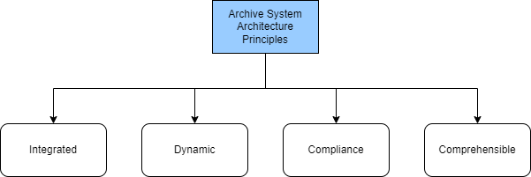
- Archive system architecture principles
The integrated principle contained in the SPBE in the archives sector is to become a unified whole that is easy to understand and use comprehensively, so an architectural concept is needed that facilitates the integration of complete data. The current problem with ANRI is the unavailability of an integrated national archive system. The ANRI archive system is divided according to its management function of the Dynamic Archival Information System (SRIKANDI), the Static Archive Management Information System (SIKS), the National Archives Management Information System (SIKN), and the National Archives Information Network (JIKN). Those systems are not fully integrated, which induces the input process on each system still conduct the recurrence process. Service-based computing methods by [4] support the integrated principle by providing a service architecture concept that makes it easy to integrate various business services. Huang and Meng's study in [5] developed a record administration service system utilizing service architecture in transmitting data. The integrated principle can be fulfilled by applying the service architecture concept.
In complement to fulfilling the necessity for integrated principles in every business service, a mapping between business service needs and IT service needs is required. Mapping and identification between archival business services and IT services must be made so the transformation can run harmoniously. Service Computing System Engineering (SCSE) is a methodology that incorporates a service computing framework in a series of life cycles that fosters the systematic and persistent design and implementation of systems that can specify the requirements of IT services and business services [6]. Accordingly, this approach can be used to map the essentials of IT and business services to generate innovations in archival services.
The formation of innovation in archival services must heed the dynamic principle. The architecture must be dynamic to move quickly to changes and developments in government functions and information and communication technology, so swift, flexible, and dynamic service development methods are needed. The Service-Oriented-Architecture (SOA) method is the foundation for devising a service-based computing paradigm by [7] encouraging microservice architectures' emergence. In contrast to SOA, microservice architecture takes a simple service development technique that focuses on one functionality to work effectively to eliminate the complexity of SOA [8]. Microservices facilitate the development of containerization that helps a lightweight approach [9], rapidly constructing collaborative services [10], and being adaptable to rapid and continuous business transformations [11]. Moreover, it has characteristic functions that can be used, enhanced, and independently tested [12]. Thus, the application of microservice architecture to archive management services is expected to meet dynamic business necessities, in line with the rapid growth of IT services.
In addition to the integrated and dynamic principles, compliance is the third principle required in designing the architecture of the national archives service. The principle of compliance requires that the architecture be designed based on policies, laws, and regulations, as well as national and international standards regarding archives. One of the government regulations governing archive storage is contained in Article 66 of the Law of the Republic of Indonesia Number 43 of 2009 about Archives needing to store archives for 25 years. Corresponding with the national regulations, the Open Archival Information System (OAIS) reference model is an international standard in ISO 14721:2012 in electronic archive data storage. Tripathi's study in [13] developed the preservation of digital records by packaging entities and metadata of digital records for reusability. Also, Rahmanto and Riasetiawan's study in [14] develops an OAIS-based digital record repository system for data preservation strategies. Implementing OAIS as a digital preservation framework makes the compliance requirements achievable in designing the national archival platform system that aligns with corresponding regulations and standards.
The last principle in archival SPBE is comprehensible, which requires the architecture to be easy to understand and uncomplicated. The method used by [15] states that the platform can integrate different and complex service systems into one container that can be easily understood and used by other parties. Further, the service platform method proposed by [16] can involve several services that are integrated as an entirety. Accordingly, the concept of a service platform is required to design a national archival platform system that implements the comprehensible principle.
The research that supports integrated, dynamic, compliance, and comprehensible have drawbacks of not comprehensively fulfilling all principles. Building an integrated archive service system requires a combination of several methods and technologies. The application of the service platform method is expected to provide convenience for all ANRI stakeholders in meeting the needs of archival services. The platform design utilizes microservices in [17] as an architecture to increase flexibility and service availability. The methodology used in designing the archive management system platform is SCSE [6] to identify business service needs and IT services in creating service innovations by using the OAIS reference model as a service design reference. Thus, this research is intended to design a national archival platform system based on the combination of microservice-based platform design methods using SCSE complement with OAIS standard and archival SPBE principles.
The organization of this paper includes research methodology in section II, followed by the result and discussion of this study in section III. Lastly, the conclusion is available in section IV.

- METHOD
The development of a national archival system in this research employs a mixture of service computing system engineering, service platform, microservice architecture, and reference model from corresponding business methods described in Table 1. This research only uses three stages: objective and requirements, modeling, and development shown in.Fig. 2.
- Mixture Methods
SCSE | Service Platform | Microservice Modeling | Reference Model
Objective and requirements | Domain analysis |  | OAIS reference model
Modeling | Platform architecture design | Microservice modeling process | Mapping
Development | Core assets implementation
The objective and requirements stage in SCSE is comparable to the domain analysis on the engineering platform, as well as the development stage in SCSE with core assets implementation on the engineering platform. However, the activities in SCSE are more detailed, so SCSE becomes the basis for combining research methodologies. This stage combines the OAIS reference model to produce standard-compliant business processes. The SCSE modeling stage includes microservice modeling activities such as identifying microservice candidates and identifying common and derived features. In addition, mapping activities to the OAIS reference model were added to ensure that the resulting model complies with the standard.
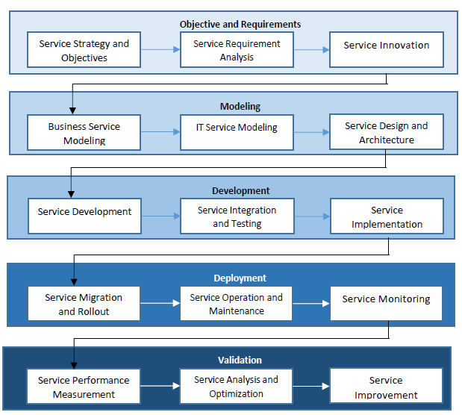
- Stages in SCSE Framework

2.1. Objective and Requirements Stage
The Objective and Requirements stage identifies service strategies, objectives, needs, and innovations. The implementation of this stage must be based on the organization's strategy and business needs and improve the organization's business services. This stage includes 3 phases: service strategy and objectives, service requirements, and service innovation. All phases, steps, and artifacts in the objective and requirements stage are shown in Fig. 3. It shows the improvised SCSE artifacts utilizing OAIS as a reference model.

2.1.1. Service Strategy and Objective Phase
In this phase, identification is carried out related to the organization's business goals and strategies. Details of the activities carried out in determining service strategy and objectives at ANRI are shown in Table 2.
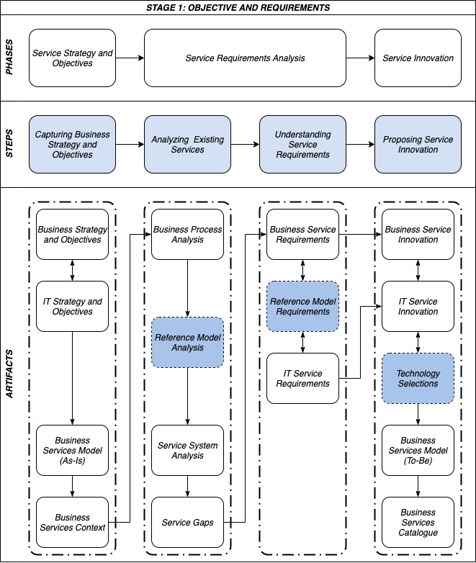
- Objective and Requirements Stage
- Service Strategy and Objective Phase
Activities
- Identify business strategies and objectives in archive management at ANRI
- Identify IT strategies and objectives in archive management at ANRI
- Identification of records management business service model at ANRI
- Identify the context of business management services at ANRI
Input | Tool | Output
- ANRI's Strategic Plan  - Regulation of the Head of ANRI | - Value Chain  - Business Model Canvas (BMC)  - Context Diagram | - Business strategy and goals  - IT strategy and goals  - BPMN As-Is  - Business service context  (Context Diagram, Stakeholder Diagram)

2.1.2. Service Requirement Analysis Phase
In this phase, the ongoing service analysis process is carried out to identify the needs of business services and IT services related to the archive management process. A new artifact of the reference model analysis process is added in this phase. The reference model analysis process is needed to map service requirements with related service standards, which consist of existing business services and IT services. Thus, adding a reference model needs analysis can complement the needs of business services and IT services that meet the needs of organizations according to standards. The process and analysis of service requirements can be obtained from reports and feedback on the performance of existing systems, needs and evaluations from users who use the system, and needs and evaluations from reference models related to digital archive management. Details of the activities carried out to identifying service requirements are shown in Table 3.
- Service Requirement Analysis Phase
Activities
- Analysis of ongoing records management business processes
- Analysis of the digital archive management reference model
- Analysis of the ongoing archive management service system
- Ongoing service system gap analysis
- Identify business service needs
- Identify the need for an electronic archive reference model
- Identify IT service needs
Input | Tool | Output
- Outputs from the service strategy and objective phase  - ANRI Standard Operating Procedures (SOP) related to the archive management process  - Digital archive management reference model | - Business Model Canvas (BMC)  - Table | - BPMN As-Is  - OAIS reference model analysis results  - Service system analysis results  - Service gap  - Business service needs  - The need for an electronic archive reference model  - IT service needs

2.1.3. Service Innovation Phase
The results of identifying business service needs, reference models, and IT services are used for the development of service innovation. In this phase, a new business service model is proposed to produce a service innovation. The technology selection artifact is added as a set of technologies needed to improve the new model. The business service catalog artifact contains the list of business service innovations that align with the IT services innovations. Details of the activities carried out to determine service innovation are shown in Table 4.
- Service Innovation Phase
Activities
- Identify business service innovations based on business service needs
- Identify IT service innovations based on IT service needs
- Identify the technological approach to be used
- Identify new business service models based on business service innovation and IT service innovation
- Identification of business service catalog
Input | Tool | Output
Outputs from the service requirements phase | - Business Model Canvas (BMC)  - Table | - List of business service innovations  - List of IT service innovations  - Result of identification of technology approach  - BPMN To-Be  - Business service catalog

2.2. Modeling Stage
The focus of the modeling stage is to design the model and architecture of the service system platform. Modeling includes business services and IT services. The IT services are software services that support the implementation of business services. This stage consists of the business service modeling, IT service modeling, and service design and architecture phases. All stages, phases, and artifacts in the modeling stage are shown in Fig. 4.
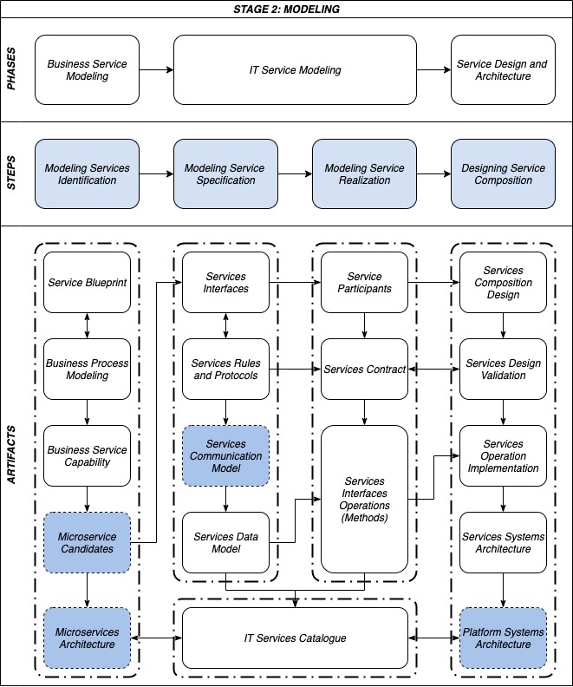
- Modeling Stage

2.2.1. Business Service Modeling Phase
In this phase, the identification of business services relevant to the records management business process at ANRI is carried out based on the business service innovations proposed in the previous stage. Business service modeling helps identify business services' capabilities and explain in detail what services do and how they interact. Business service capabilities can be defined based on service objectives and the description of business processes. Details of activities carried out in business service modeling are shown in Table 5.
- Business Service Modeling Phase
Activities
- Service activity modeling according to the business service catalog
- Modeling of new business processes based on proposed business service innovations
- Identification and modeling of business service capabilities
- Identification and modeling of microservices
Input | Tool | Output
- Outputs from the service requirement and innovation phase | - Service Blueprint Diagram  - Business Process Model Notation (BPMN)  - SoaML  - Table | - Service blueprint  - BPMN To-Be  - Service capabilities (SoaML) modeling results  - Microservice candidates (SoaML) modeling results

2.2.2. IT Service Modeling Phase
The service modeling aims to realize IT services that are able to support the implementation of business services. In this phase, service specifications and service realization are modeled. Activities in this phase use the Service Oriented Architecture Modeling Language (SoaML). Added service communication modeling because microservice architecture differs from SOA, which can communicate without Enterprise Service Bus (ESB). Thus, microservices can use several communication models between each internal service and internal with external services. The entire process carried out in this phase is a catalog of IT services. Details of the activities carried out in the IT service modeling are shown in Table 6.
- IT Service Modeling Phase
Activities
- Service interface modeling
- Modeling service rules and protocols
- Service communication model modeler to define the communication model used
- Modeling service data model to define the data used
- Modeling service participants which can be in the form of organizations, systems, or individuals
- Service interface operation modeling
- Identification of IT service catalog
Input | Tool | Output
Outputs from the business service modeling phase | - SoaML  - Table | - Service interface model (SoaML)  - Model service rules and protocols (SoaML)  - Service communication model  - Model service data model (SoaML)  - Service participant model (SoaML)  - Model service interface operations (SoaML)  - IT service catalog

2.2.3. Service Design and Architecture Phase
In this phase, the service composition design and the platform's architecture are carried out. Also, an evaluation of the service composition design is conducted. Details of activities in this phase are shown in Table 7.
- Service Design and Architecture Phase
Activities
- Perform service composition that describes the interaction between service participants
- Conducting service design evaluation
- Modeling the implementation of service operations in detail
- Perform service architecture modeling
- Service computing system platform architecture design
Input | Tool | Output
- Outputs from the IT service modeling phase | - SoaML  - UML (sequence diagram)  - Table | - Service composition model (SoaML)  - Service design evaluation results  - Service operation details (activity diagram)  - Service architecture (SoaML)  - Service computing system platform architecture

2.3. Development Stage
The main activity at this stage is the development of IT service systems in the form of implementing service designs and architectures that have been produced in the previous stage. This stage consists of a service development phase, service integration and testing, and service implementation. All stages, phases, and artifacts in the development stage are shown in Fig. 5.
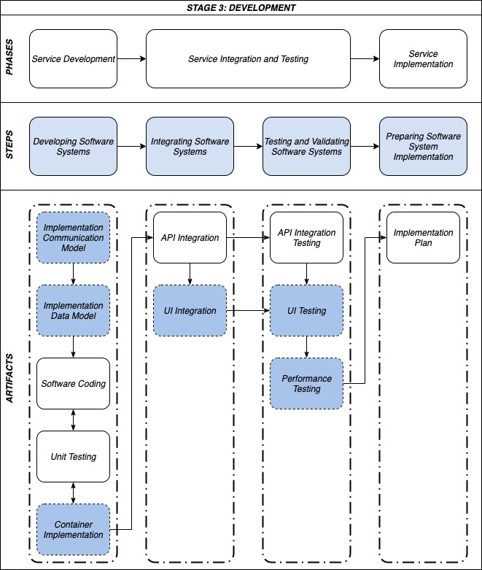
- Development Stage

2.3.1. Service Development Phase
In this phase, the service design is implemented into the software. Implementation includes software programming and microservice unit testing. The addition of communication model artifacts, data models, and container implementations are added to accommodate the use of microservice architecture. Details of activities in this phase are shown in Table 8.
- Service Development Phase
Activities
- Implementation of data schemas into databases
- Perform programming according to the resulting service design
- Perform unit testing of microservices that are built
Input | Tool | Output
Output from the service modeling phase | - Text editor  - Container  - Database Management Tool  - Unit Testing Tool | - Databases  - Source codes  - Microservices  - Microservice unit test results

2.3.2. Service Integration and Testing Phase
Service integration is carried out in this phase to realize the overall system platform. Furthermore, testing the entire system platform is carried out according to the designed service model to ensure that the system platform is functioning properly. Details of activities in this phase are shown in Table 9.
- Service Integration and Testing Phase
Activities
- Integration of multiple microservices
- Grouping microservices into containers
- Perform microservices integration testing
- Integration with front end system
- Perform functional testing
- Perform integration testing
- Perform initial performance testing
Input | Tool | Output
Outputs from the service development phase | - Text editor  - Container  - Functional and Integration Test Tool  - Initial Performance Test Tool | - Source code for integration  - Front-end system prototype  - The results of functional testing  - The results of integration testing  - The results of initial performance testing

2.3.3. Service Implementation Phase
In this phase, a service implementation plan is prepared in order to deploy the validated platform system into the production environment. Therefore, the service can be appropriately used by users. Details of the activities carried out in this phase are shown in Table 10.
- Service Implementation Phase
Activities
Prepare the implementation plan of the system platform into the production environment
Input | Tool | Output
Outputs from the service design and architecture phase | Word processing | Implementation plan

2.4. Evaluation
Evaluation in this research consisted of the evaluation of design and performance. Design evaluation is helpful to ensure that the design is in accordance with service-based principles, while performance evaluation is needed to see the extent to which the level of availability of the system platform built can meet user needs. These two evaluations are an essential part of the development of this system platform.

2.4.1. Design Evaluation
Service design evaluation includes measuring the value of the service design's coupling factor, cohesion factor, complexity, and reusability [18]. Evaluation is carried out based on interactions between services and operations within and with other services.

2.4.1.1. Coupling Factor ($CopF$)
The coupling factor measures the dependence of the interaction between services and their elements in a system. The smaller the value of the coupling factor, the better the service system design. The formula for generating the coupling factor value is as follows:
$$CopF\left(p\right)=\frac{IC\left(p\right)}{f^{2}-f}$$
$$IC\left(p\right)=DC\left(p\right)+\sum_{c(p)∈P}{IC(c(p))}$$
$$f=NS(SOS)+NO(SOS)$$
(1)
With:
$c$ = Number of consumers
$p$ = Number of providers
$DC(p)$ = Number of direct couplings
$IC(p)$ = Number of indirect couplings
$f$ = Number of services and operations
$NS(SOS)$= Number of services in the service-oriented-system
$NO(SOS)$ = Number of operations in the service-oriented-system
$CopF(p)$ = Coupling factor of the service-system

4.1.2. Cohesion Factor (CohF)
The cohesion factor measures the strength of the relationship between operations in service. The greater the value of the cohesion factor, the better the design of the service system. The formula to generate the cohesion factor value is as follows:
$$CohF\left(s\right)=\frac{CM\left(s\right)}{f^{2}-f}$$
$$CM\left(s\right)=\{c(p)|(c∈C)∧(p∈P)∧(c∧p)∈s\}$$
(2)
With:
$CM(s)$ = The value of the cohesion metric of the service
$f$ = Number of services and operations in the service-oriented-system
$CohF(s)$ = Cohesion factor of the service

2.4.1.3. Complexity Factor
The complexity factor measures the level of complexity of a service system. The smaller the value, the better the service system design. The complexity factor can be calculated from the coupling factor and cohesion factor for each service with the following formula:

$$ComF\left(s\right)=\frac{CopF\left(s\right)}{CohF(s)}$$
(3)
$CopF(s)$ = Coupling factor of the service
$CohF(s)$ = Cohesion factor of the service
$ComF(s)$ = Complexity factor of the service

2.4.1.3. Reusability (ResF)
A measure of high service reusability is indicated by a high level of cohesion and a low level of coupling. In other words, services with little direct interaction and high cohesion value will be more reusable. The formula for measuring reusability is as follows:
$$ResF\left(s\right)=\frac{CM\left(SOS\right)}{DC(SOS)}$$
(4)
With:
$CM(SOS)$ = The value of indirect coupling of the service-oriented-system
$DC(SOS)$ = The value of direct coupling of the service-oriented-system
$ResF(s)$ = Reusability factor

2.4.2. Performance Evaluation
The purpose of performance evaluation is to measure the performance of the formed system platform. Dependability is a performance measurement method that shows that the system has a level of confidence in successfully serving user requests with an acceptable possibility of failure [19]. There are five tests of reliability, availability, integrity, safety, and maintainability on the dependability attribute. In this study, the availability test is used to measure the performance of the platform in accordance with the research objectives.
In a service computing system, various possible events such as failure, attack, repair, or recovery cause various states or conditions that affect the system's ability to receive and provide services to users. Fig. 6. shows that there are ready and failed categories in the state.
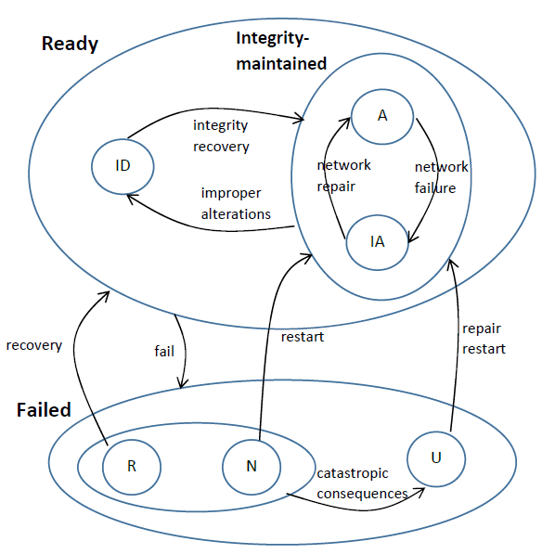
- Avalability State
The availability attribute indicates the probability that the system is ready and accessible by the user at time T. The probability value can be obtained by using the following formula:
$$A={Pr}_{s}(A)=\lim_{T→∞}{\frac{1}{T}}\int_{0}^{T}{\operatorname{Pr}\left(Accessible\left(t\right)\right)=π_{A}}$$
(5)
With:
$A={Pr}_{s}(A)=π_{A}$ = The probability of the system is in a ready state and can be accessed at time T
$Accessible(t)$ = Event of the system in the accessible state at time t

- RESULTS AND DISCUSSION (10 PT)
The section consists the results of the research to design the national archival platform system with the use of microservice-based SCSE framework.

3.1. Objective and Requirements Stage
The results of the objectives and requirements stages that have been carried out will be presented in this section. The service strategy and objective phase, the service requirements analysis phase, and the service innovation phase will display artifacts as the output of the research results.

3.1.1. Business Strategy and Goals
Business strategy and objectives must be aligned with the organization's vision and mission. The organization's vision and mission are guidelines for compiling various things such as goals, strategic objectives, strategies, and work programs. Based on the strategic plan document, ANRI has set the vision and mission for 2020 – 2024 as follows [3].
One of the objectives of ANRI's strategy to support the ANRI’s mission is to study and develop the archive system, which is ANRI's business strategy related to this research. Every activity in the organization should produce added value for the organization in achieving its goals. The value chain of the national archives management process is described through a value chain diagram to identify the main and supporting processes. The value chain of the national archives sector is depicted in Fig. 7.
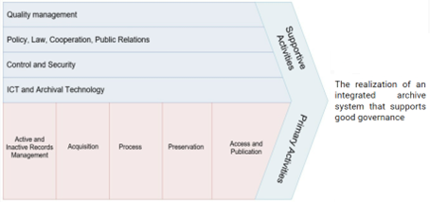
- National Archive Value Chain

3.1.2. Business Service Context
Identification of the service scope is needed to describe the service in general. Context diagrams are formed to be able to display the flow of information processed by a service to provide an overview of the system as a whole. Fig. 8. shows the scope of the national archive management service at ANRI.
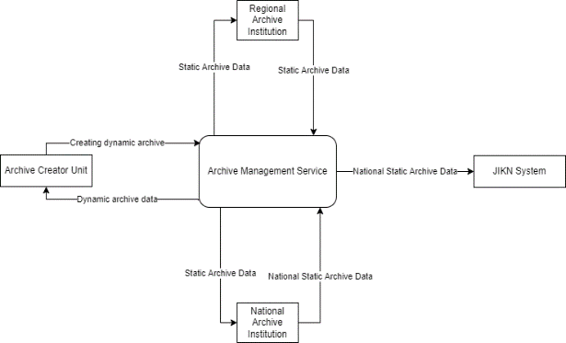
- National Archive Context Diagram
The results of identifying related parties in the archives sector are mapped into the stakeholder map matrix, as shown in Table 11.
- Stakeholder Map Matrix
Stakeholders | Description
Archive Creator Units | Parties who have independence and authority in the implementation of functions, duties, and responsibilities in the field of dynamic archive management
Archive Processing Units | The work unit for archive creators who have duties and responsibilities to process all archives related to archive creation activities in their environment
Archive Institutions | Institutions that have functions, duties, and responsibilities in the field of static archive management and archiving development
ANRI | Archival institutions in the form of non-ministerial government institutions that carry out state duties in the field of archives
Public | Indonesian citizens

3.1.3. Business Process Identification and Analysis
The main activities in managing national archives have been previously identified through the value chain in Fig. 7. Furthermore, business functions are broken down into more specific business processes. The following is the result of the identification of business functions and business processes related to the management of national archives described in Table 12.
- Ongoing Records Management Business Functions and Business Processes
Business Functions |  | Business Processes (As-Is)
BF1 | Dynamic Archive Management | BP1 | Archive Creation and Reception
BF1 | Dynamic Archive Management | BP2 | Archive Usage
BF1 | Dynamic Archive Management | BP3 | Archive Maintenance
BF1 | Dynamic Archive Management | BP4 | Archive Shrinkage
BF2 | Static Archive Management | BP5 | Archive Acquisition
BF2 | Static Archive Management | BP6 | Archive Processing
BF2 | Static Archive Management | BP7 | Archive Preservation
BF2 | Static Archive Management | BP8 | Archive Access and Publication
After the description of the business process, the ongoing business process modeling is carried out based on Table 12. Modeling is done to show a complete picture of the overall relationship of the business process from start to finish. Fig. 9. describes the relationship between business processes categorization.
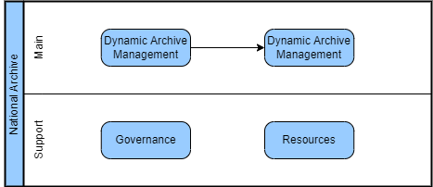
- National Archive Business Process

3.1.4. OAIS Reference Model Analysis
Based on the business process analysis above, digital archive preservation needs to be carried out to protect the value of digital archives so they remain authentic and can be accessed and reused by agencies and the public. The OAIS model as a reference model for digital archive preservation provides services for digital preservation needs to meet records management standards as stated in ISO 15489-1:2001, ISO 15489-2:2001, ISO 23081-1:2006, ISO 23081-2:2007, and ISO 16363:2011. In Fig. 5. and Table 13. , services in the OAIS model involve three actors: creators, users, and management.
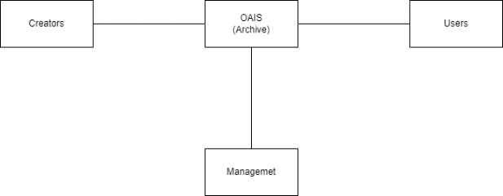
- OAIS Actors
- Description of OAIS Model Actors
Actors | Description
Creators | The party who creates an information that requires preservation
Users | The party who seek and use the information that has been preserved
Management | The party that regulates policies, controls and responsibilities in the management of archive preservation
The three actors are in accordance with the needs of ANRI's business processes described previously, which consist of archive users, ANRI and archival institutions, and archive creators. The OAIS model has six functional services involving the three actors, which are described in Table 14.
- OAIS Model Functional Services
No | OAIS Services | Description
SO1 | Processing | A service for packaging digital archives that are stored with the addition of metadata information prepared for the convenience of archive storage and data management services
SO2 | Archive Storage | A service for storing digital archive documents that can be maintained, backed up, and error checking
SO3 | Data Management | A service for managing digital archive description information.
SO4 | Administration | A service to monitor the digital archive process for compliance with standards and policies, which also provides archive reports
SO5 | Preservation | A service consists of the archive preservation process, so it can be accessed and stored for a long time
SO6 | Access | A service provides receiving and requesting access to digital archives

3.1.5. IT Service Innovations
IT services firmly support business services, so innovation in IT services becomes the enabler for business service innovation. The identification of IT service innovations that support the management of national records is shown in
- IT Service Innovation for National Archive Platform
No | IT Service Innovations | Description
TS1 | User Management | A service for managing users’ data for authentication and authorization access
TS2 | Archive Management | A service for managing electronic archives
TS3 | Agency Management | A service for managing involved stakeholders
TS4 | Digital Certificate Management | A service for managing users’ digital certificate
TS5 | Event Management | A service for managing event
TS6 | Acquisition | A service for acquiring dynamic archives from creators
TS7 | Processing | A service for processing dynamic archive to ensure the archival’s metadata standard
TS8 | Preservation | A service providing integrity and periodic back up for archival data
TS9 | Publication and Access | A service providing publication and access for static archives
TS10 | Notification | A service providing notification features
TS11 | Signing | A service for signing events and digital documents
TS12 | Verification | A service providing verification for archival processes

3.2. Modeling Stage
This section describes the modeling phase's results, including modeling business and IT services. This stage displays the results of the business service modeling, IT service modeling, and service design and architecture phases. The output of the research results in each phase are artifacts created using SoaML and service blueprints and BPMN in business service modeling.

3.2.1. Microservice Platform
After obtaining a catalog of IT service innovations and mapping them into candidate microservices, then grouping these microservices into core and special services shown in Fig. 11. The unified records management platform has core services that special services can leverage.

3.2.2. Service Design Validation
At this stage, an evaluation of the service design will be carried out. The evaluation includes the suitability of the service with the four main principles of SOA design, namely coupling, cohesion, complexity, and reusable. The interaction of each service is also evaluated to measure each service's loose coupled shown in Fig. 12.
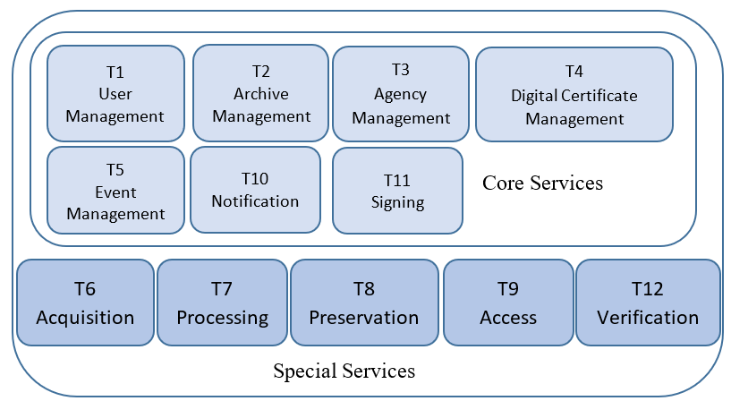
- Microservice Candidate Grouping
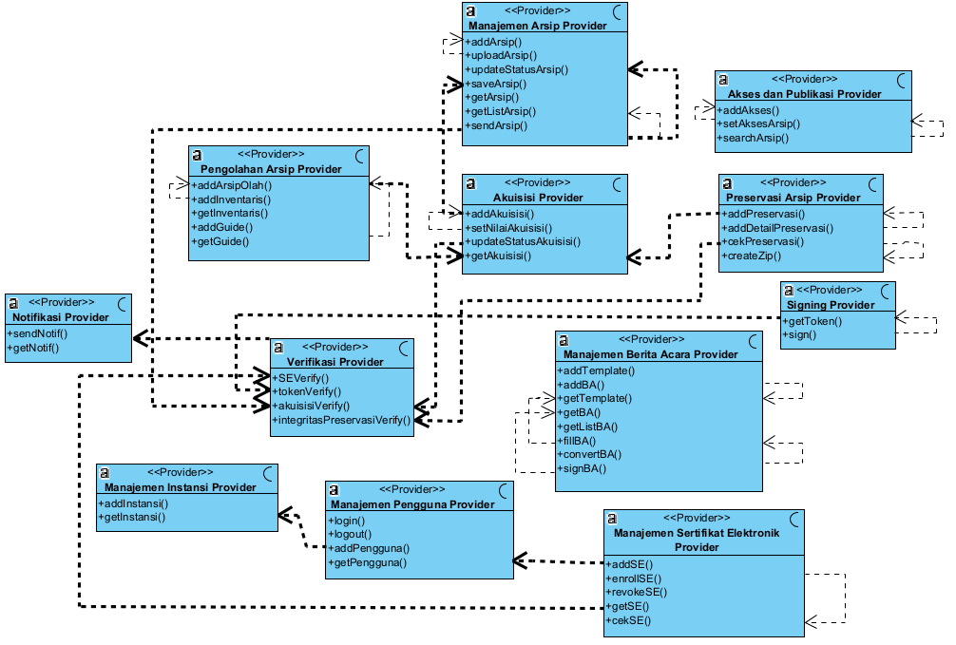
- Service Interaction Diagram

3.2.2.1. Coupling Value
The coupling parameter measures the level of dependency between services in a system. A good system has a low dependence between services, which is called loosely coupled. The desired value is close to 0. Based on the modeling that has been done, the following calculations are obtained.
- Coupling Operation
Operations | Count
Number of Service (NS) | 12
Number of Operation (NO) | 48
F(NS+NO) | 60
$$CopF\left(p\right)=\frac{10}{{60}^{2}-60}=0.00282$$
The coupling factor value obtained is 0.00282, indicating that the level of dependence between services is low. Therefore, the service design is loosely coupled.

3.2.2.2. Cohesion value
The cohesion parameter is used to measure the level of component attachment. In this case, the operation in service and system. Two parameters show the cohesion value, Cohesion Metric (CM) to measure the Cohesion value in service, and Cohesion Factor (CohF) to measure the Cohesion Value in the whole system.
- Cohesion Metrics
Services | CM(s) | I | CohF(s)
User Management | 4 | 5 | 0.026836158
Archive Management | 7 | 8 | 0.124294
Agency Management | 2 | 3 | 0.004237
Digital Certificate Management | 4 | 5 | 0.026836158
Event Management | 7 | 8 | 0.124294
Acquisition | 4 | 5 | 0.026836158
Processing | 5 | 6 | 0.049153
Preservation | 4 | 5 | 0.026836
Access and Publication | 3 | 4 | 0.012429
Notification | 2 | 3 | 0.004237288
Signing | 2 | 3 | 0.004237288
Verification | 4 | 5 | 0.026836158
Cohesion Factor Value |  |  | 0.457062

3.2.2.3. Complexity Value
The complexity value parameter is used to assess the level of complexity of the interaction between services and operations in a service system.
$$ComF\left(s\right)=\frac{0.0028}{0.457}=0.0062$$

3.2.2.4. Reusability Value
The reusability value parameter is used to assess a system's service usage level. The approach is to use a system's cohesion and coupling values. A good system has a high reusability value if the level of cohesion is high while the level of coupling is low.
$$ResF=\frac{48}{10}=4.8$$

3.3. Development Stage
System development based on the design that has been carried out in the previous stage will be explained at this stage. The results of this stage include the service development phase, the service integration and testing phase, and the service implementation phase, which will display several artifacts as the output of the research results.
Implementation of the system design into service-based applications is carried out in the service development phase. Development is carried out in the form of a prototype to determine the suitability between the design that has been carried out and the time of implementation. The implementation results include the communication model, data model, software coding, and unit test testing for each operation contained in the service.
The service communication model is applied to communication between internal services and external services. Internal service communication is carried out by implementing access control to register internal services so that they can communicate between services. Laravel Passport is used to create an API gateway based on Oauth2 as a standard user authorization protocol and secure secret code using JWT. Fig. 13. shows the services authorized to access internal communication.
This research's service development utilizes PHP and Go programming languages. The PHP programming language is included in the interpreter category, while the Go programming language is included in the compiler category. The PHP programming language will be used in most services due to its faster development, but for services that have a high load, it will be developed using Go which has better performance. Fig. 14. shows the use of programming languages and databases used on the platform.
- List of clients on API gateway in oauth_clients table
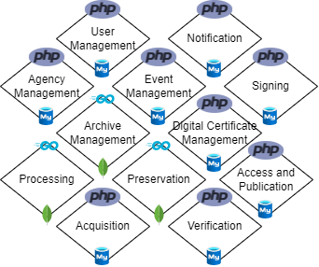
- Service Coding Resources
Codeception is used for the creation of test scenarios. The tests carried out include unit testing, functional testing, and integration testing. Fig. 15. is an example of a test scenario for integrating the service into the frontend system showed in Fig. 16.
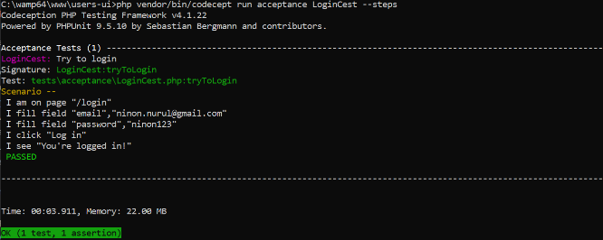
- Integration Testing for Login
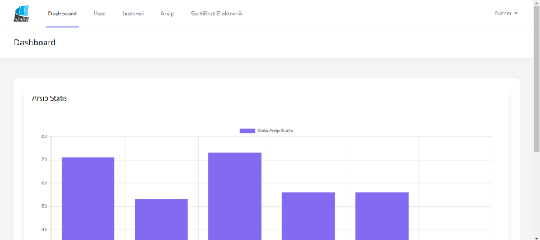
- Frontend System Integration
Another test conducted in this research is performance testing. Performance testing evaluates the system built in terms of stability to ensure that the system is responsive to user access needs. Performance testing includes evaluating response time, service availability, and system robustness in serving user access requests.
Data on archive creation uses 600.000 data, creating dynamic archives in ten agencies in one year. Performance testing is carried out on services considered crucial to ensure the archiving process's availability. Table 18. summarizes the performance test results on some predefined operations to estimate the number of containers used for each service.
- The Result of Performance Testing
No | Operations | Services | Num of Containers | Pr  (A)
TS1 | logIn | User Management | 1 | 1
TS2 | addArchive | Archive Management | 2 | 0.9
TS3 | getListAgency | Agency Management | 1 | 1
TS4 | revokeDC | Digital Certificate Management | 1 | 1
TS5 | fillEvent | Event Management | 1 | 1
TS6 | getAcquisition | Acquisition | 2 | 0.9
TS7 | addGuide | Processing | 1 | 0.9
TS8 | createZip | Preservation | 1 | 1
TS9 | searchArchive | Access and Publication | 2 | 0.9
TS10 | sign | Signing | 1 | 0.9
TS11 | sendNotif | Notification | 1 | 1
TS12 | verifyToken | Verification | 1 | 1

- CONCLUSION (10 PT)
This research proposed designing a national archival platform system using an SCSE microservice-based framework. The framework facilitates the SPBE principles in archives and the OAIS reference model. The utilization of microservice architecture promotes rapid development while the platform simplifies the integration into various systems. The service design validation was conducted to measure a system design's quality by performing coupling, cohesion, complexity, and reusability factor. The four factors are satisfied with the values of 0.00282, 0.457062, 0.0062, and 4.8 for coupling, cohesion, complexity, and reusability. Further, the measurement of the system's availability is employed to provide the specification of the platform's resources. Future works can focus on the integration of diverse archival metadata and archival security mechanisms.

REFERENCES
- G. Vial, “Understanding digital transformation: A review and a research agenda,”. The Journal of Strategic Information Systems, vol. 28, no. 2, pp. 118–144, 2019.
- T. Kharisma, and L. Agustina, “Application of digital public relations management in public communications at the National Archives Agency of the Republic of Indonesia,” Diakom: Jurnal Media Dan Komunikasi, 2(1), 112-119, 2019.
- National Archives of the Republic of Indonesia, “Architecture and electronic-based government system plan in the National Archives of the Republic of Indonesia, 2020-2024”, 2020.
- Y. Chen, and G. D. Luca, “Technologies for developing a smart city in computational thinking,”. International Journal of Simulation and Process Modelling, 13(2), 91-101, 2018.
- S. Huang and X. Meng, “Research and application of integration solution for enterprise-level heterogeneous document management systems,” Journal of Physics: Conference Series, vol. 1621, no. 1, p. 012109, 2020.
- N. B. Kurniawan, Suhardi, Y. Bandung, and P. Yustianto, “Services computing systems engineering framework: a proposition and evaluation through SOA principles and analysis model,” IEEE Systems Journal, vol. 14, no. 3, pp. 3105–3116, 2020.
- Suhardi, N. B. Kurniawan, and J. Sembiring, “Service computing system engineering life cycle,”. Proc. EECSI, 2017.
- N. Dragoni, S. Giallorenzo, A. L. Lafuente, M. Mazzara, F. Montesi, R. Mustafin, and L. Safina, “Microservices: yesterday, today, and tomorrow,” Present and Ulterior Software Engineering, pp. 195–216, 2017.
- C. Pahl and P. Jamshidi, “Microservices: A systematic mapping study,” Proceedings of the 6th International Conference on Cloud Computing and Services Science, 2016.
- S. Newman, “Building microservices: Designing fine-grained systems”. Sebastopol, CA: O'Reilly Media, 2021.
- J. Fritzsch, J. Bogner, S. Wagner, and A. Zimmermann, “Microservices migration in industry: intentions, strategies, and challenges,” In 2019 IEEE International Conference on Software Maintenance and Evolution (ICSME) (pp. 481-490). IEEE, 2019.
- X. Larrucea, I. Santamaria, R. Colomo-Palacios, and C. Ebert, “Microservices,” IEEE Software, vol. 35, no. 3, pp. 96–100, 2018.
- S. Tripathi, “Digital preservation: some underlying issues for long-term preservation,” Library Hi Tech News, vol. 35, no. 2, pp. 8–12, 2018.
- K. N. Rahmanto and M. Riasetiawan, “Data preservation process in big data environment using open archival information system,” Proc. - 2018 4th Int. Conf. Sci. Technol. ICST 2018, 2018.
- S. Guo, C. Xu, S. Chen, X. Xue, Z. Feng, and S. Chen, “Crossover service fusion approach based on microservice architecture,” In 2019 IEEE International Conference on Web Services (ICWS) (pp. 237-241). IEEE, 2019.
- Y. A. Prasetyo, A. A. Arman, P. Yustianto, and F. T. Hartanti, “Implementation of service platform for smart city as a service”. In 2020 International Conference on Information Technology Systems and Innovation (ICITSI) (pp. 416-422). IEEE, 2020.
- B. Christudas, “Microservices in depth”. In Practical Microservices Architectural Patterns (pp. 35-53). Apress, Berkeley, CA, 2019.
- A. A. M. Elhag, and R. Mohamad, “Service-oriented design measurement and theoretical validation,”. Jurnal Teknologi, 77(9), 2015.
- J. Huang, C. Lin, and J. Wan, “Modeling, analysis and optimization of dependability-aware energy efficiency in services computing systems”, Proceeding – IEEE 10th International Conference on Service Computing, SCC 2013, 683-690, 2013.

BIOGRAPHIES OF AUTHORS

 | Taufik Iqbal Ramdhani is a researcher at Data and Information Science Research Center. He holds a bachelor's and master's degree in cybersecurity from Maranatha Christian University and Florida International University. His research interests include blockchain and public key infrastructure. He actively joined the research and development team of the digital signature implementation in iOTENTIK - BPPT since 2015. He also won several hackathon events in his home institution. As an IT auditor, he joined Indonesia's national selection committee for public service recruitment. He was also involved in securing the 2019 general election system. He can be contacted at email: tauf022@brin.go.id.
 | Ninon Nurul Faiza  completed her bachelor's degree at IPB University in 2011. After graduated, she has been an Engineer in the Agency for the Assessment and Application of Technology until now. She joined the pattern recognition laboratory to research malaria disease detection for three years. After that, she broadens her field to join the information and communication technology lab that builds various government applications for other government public services. She also researches digital signature technology in the government certification authority program. She is currently studying for a master's in information technology services at Bandung Institute of Technology. She can be contacted at email: ninon.nurulfaiza@students.itb.ac.id.

